1)Tasks To Be Performed:
1. Connect to Azure Cloud Shell
2. Create a resource group “new-rg” in South Central US region
Send the commands along with the screenshots for the completion of this
assignment.

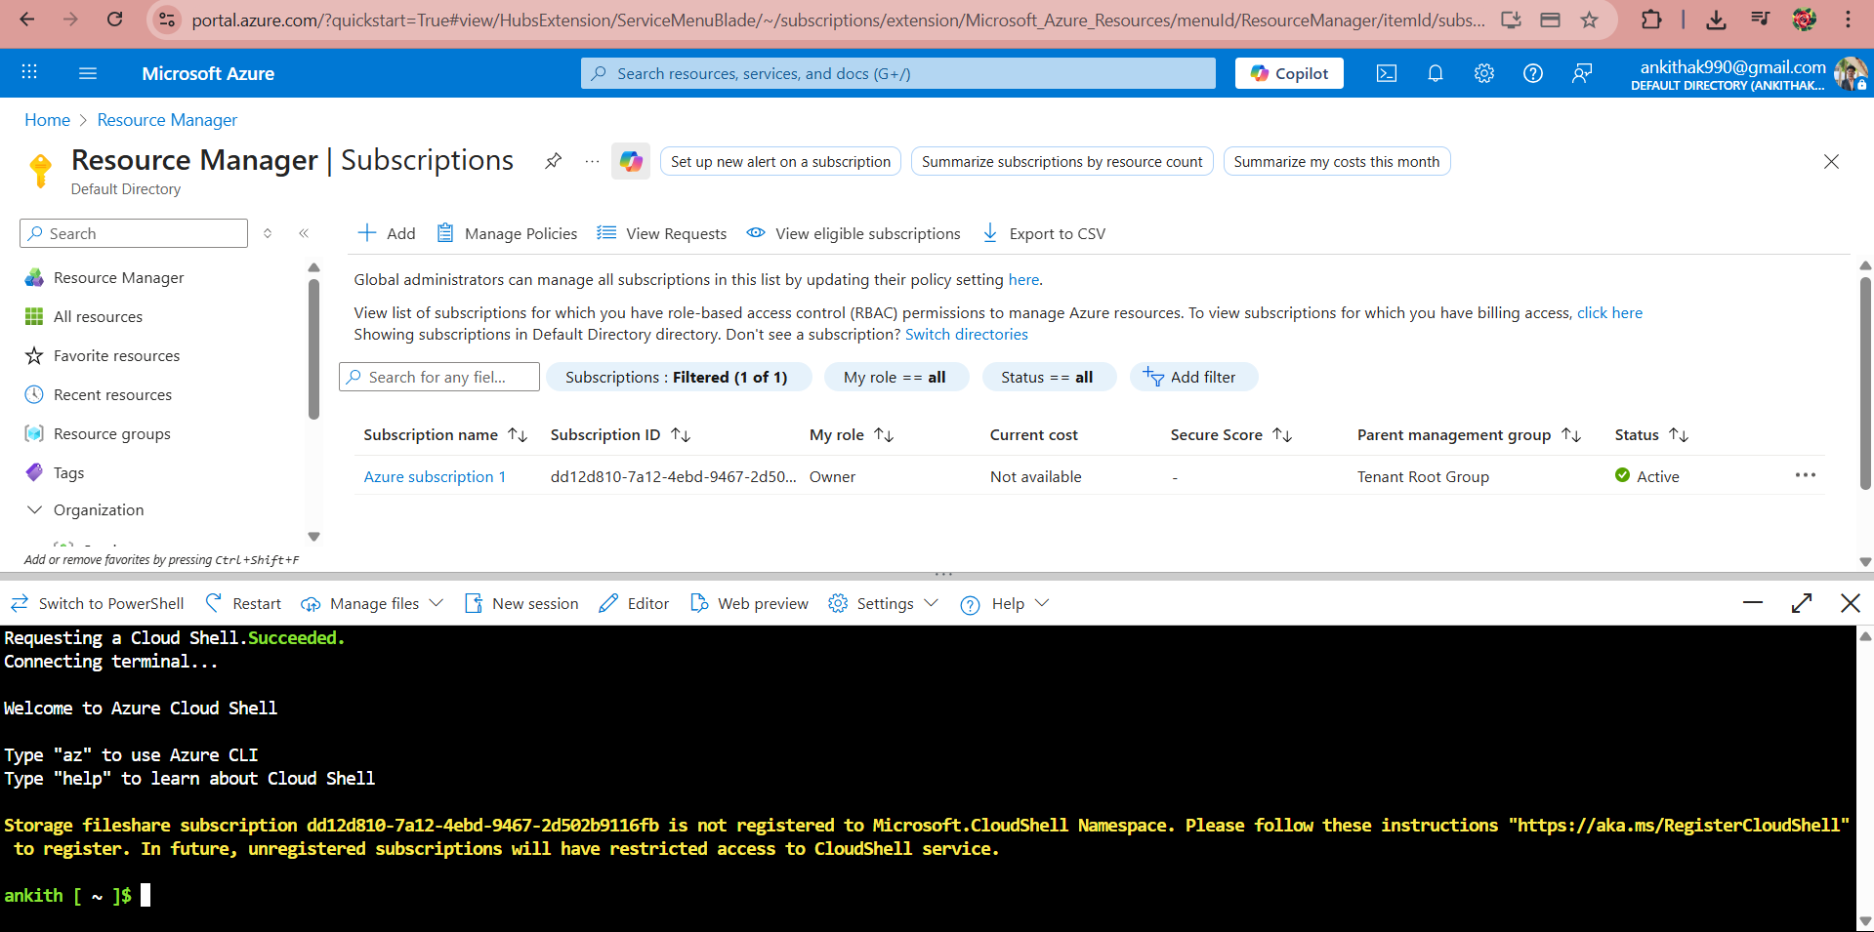
Create resource group new-rg :

ankith [ ~ ]$ az group create --name new-rg --location "South Central US"
{
"id": "/subscriptions/dd12d810-7a12-4ebd-9467-2d502b9116fb/resourceGroups/new-rg",
"location": "southcentralus",
"managedBy": null,
"name": "new-rg",
"properties": {
"provisioningState": "Succeeded"
},
"tags": null,
"type": "Microsoft.Resources/resourceGroups"
}

ankith [ ~ ]$ az group list --output table
Name Location Status
-------------------------------- -------------- ---------
cloud-shell-storage-centralindia centralindia Succeeded
new-rg

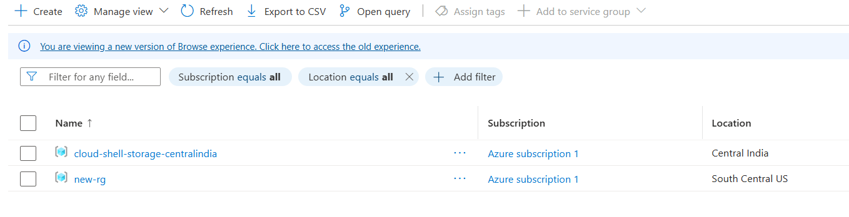
2)Tasks To Be Performed:
1. Connect Azure PowerShell to your Azure account
2. Create a new resource group in South Central US with the name
“rg-powershell”
Please submit the screenshot along with the commands.

Start Cloud Shell and switch to PowerShell
Open Cloud Shell → Select PowerShell
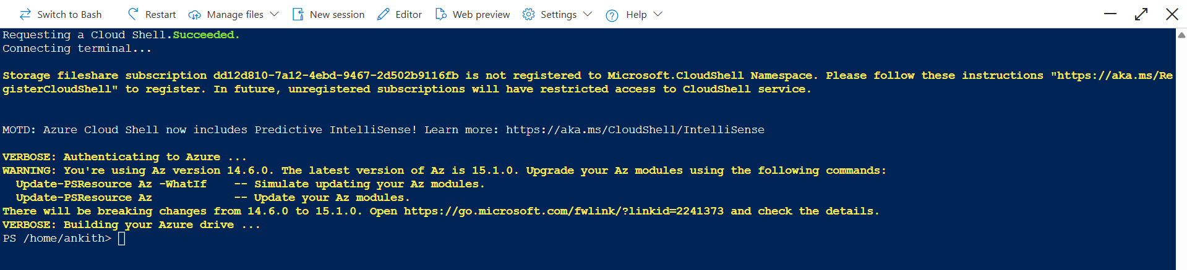
Create Resource Group rg-powershell :

Connect-AzAccount

VERBOSE: Buildi> New-AzResourceGroup -Name "rg-powershell" -Location "South Central US"
WARNING: InteractGet-AzResourceGroup
ResourceGroupName : rg-powershellt -AccessToken {AccessToken} -AccountId {AccountId} -GraphAccessToken {GraphAccessToken} -Tenant {Tenant} -Subscription {Subscription}
ResourceGroupName : cloud-shell-storage-centralindia
Location : centralindia
ProvisioningState : Succeeded
Tags : /subscriptions/dd12d810-7a12-4ebd-9467-2d502b9116fb/resourceGroups/rg-powershell
ResourceId : /subscriptions/dd12d810-7a12-4ebd-9467-2d502b9116fb/resourceGroups/cloud-shell-storage-centralindia
PS /home/ankith> Get-AzADAppCredential -DisplayName $name
ResourceGroupName : rg-powershell
Location : southcentralus
ProvisioningState : Succeeded
Tags :
ResourceId : /subscriptions/dd12d810-7a12-4ebd-9467-2d502b9116fb/resourceGroups/rg-powershell

>New-AzResourceGroup -Name "rg-powershell" -Location "South Central US"

>Get-AzResourceGroup

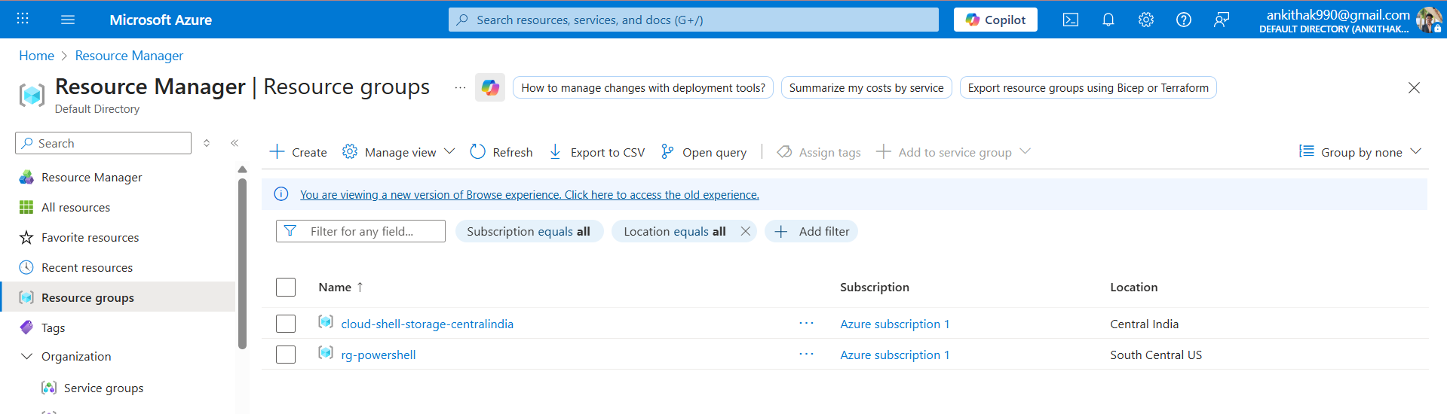
3)Tasks To Be Performed:
Use Azure CLI and Azure PowerShell to:
1. Create three more resource groups in a specific region. For example:
“West US”
2. List all resource groups in West US

Using Azure CLI (Cloud Shell – Bash) :

ankith [ ~ ]$ az group create --name rg-westus-1 --location "West US"
az group create --name rg-westus-2 --location "West US"
az group create --name rg-westus-3 --location "West US"
{
"id": "/subscriptions/dd12d810-7a12-4ebd-9467-2d502b9116fb/resourceGroups/rg-westus-1",
"location": "westus",
"managedBy": null,
"name": "rg-westus-1",
"properties": {
"provisioningState": "Succeeded"
},
"tags": null,
"type": "Microsoft.Resources/resourceGroups"
}
{
"id": "/subscriptions/dd12d810-7a12-4ebd-9467-2d502b9116fb/resourceGroups/rg-westus-2",
"location": "westus",
"managedBy": null,
"name": "rg-westus-2",
"properties": {
"provisioningState": "Succeeded"
},
"tags": null,
"type": "Microsoft.Resources/resourceGroups"
}
{
"id": "/subscriptions/dd12d810-7a12-4ebd-9467-2d502b9116fb/resourceGroups/rg-westus-3",
"location": "westus",
"managedBy": null,
"name": "rg-westus-3",
"properties": {
"provisioningState": "Succeeded"
},
"tags": null,
"type": "Microsoft.Resources/resourceGroups"
}

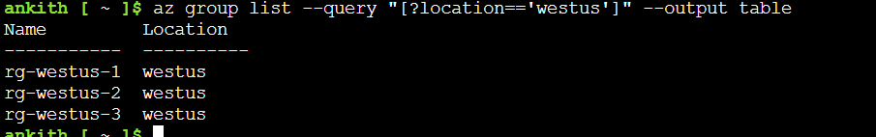
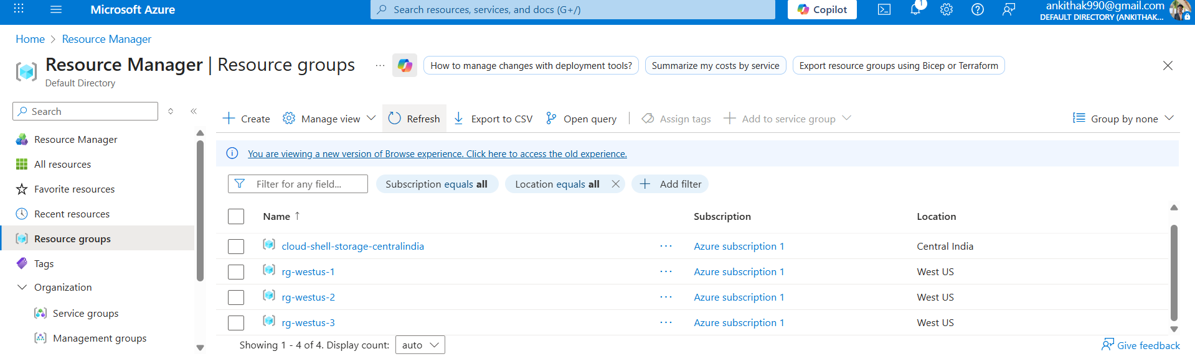

Using Azure PowerShell :

New-AzResourceGroup -Name "ps-rg-westus-1" -Location "West US"
New-AzResourceGroup -Name "ps-rg-westus-2" -Location "West US"
New-AzResourceGroup -Name "ps-rg-westus-3" -Location "West US"

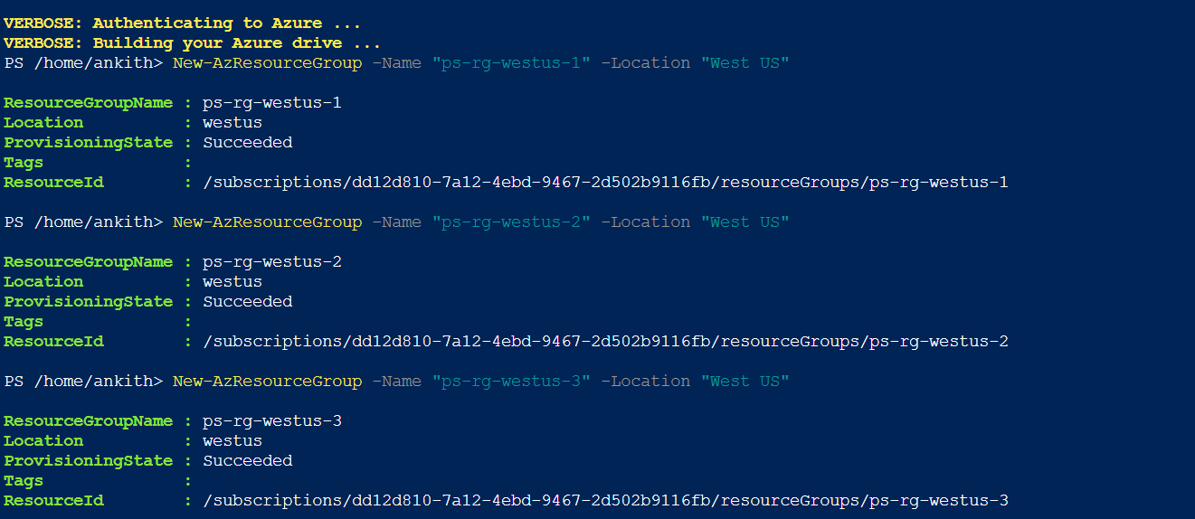
Get-AzResourceGroup | Where-Object {$_.Location -eq "westus"}

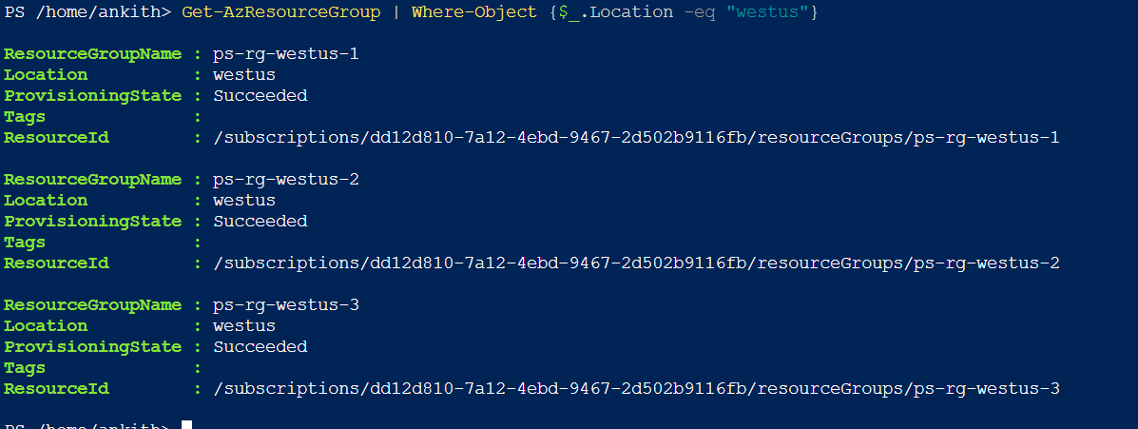
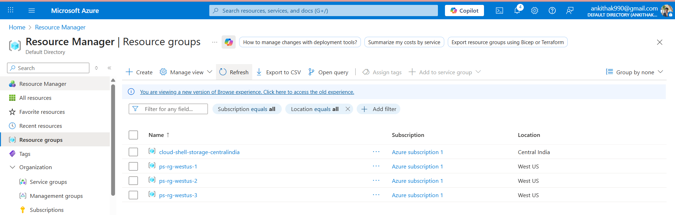
4)Tasks To Be Performed:
Use Azure CLI and Azure PowerShell to:
1. Delete all the resource groups in West US region using one command

Delete All RGs in West US

Using Azure CLI :

az group list --query "[?location=='westus'].name" -o tsv | xargs -I {} az group delete --name {} --yes –no-wait

Using Azure PowerShell :

Get-AzResourceGroup | Where-Object {$_.Location -eq "westus"} | Remove-AzResourceGroup -Force

